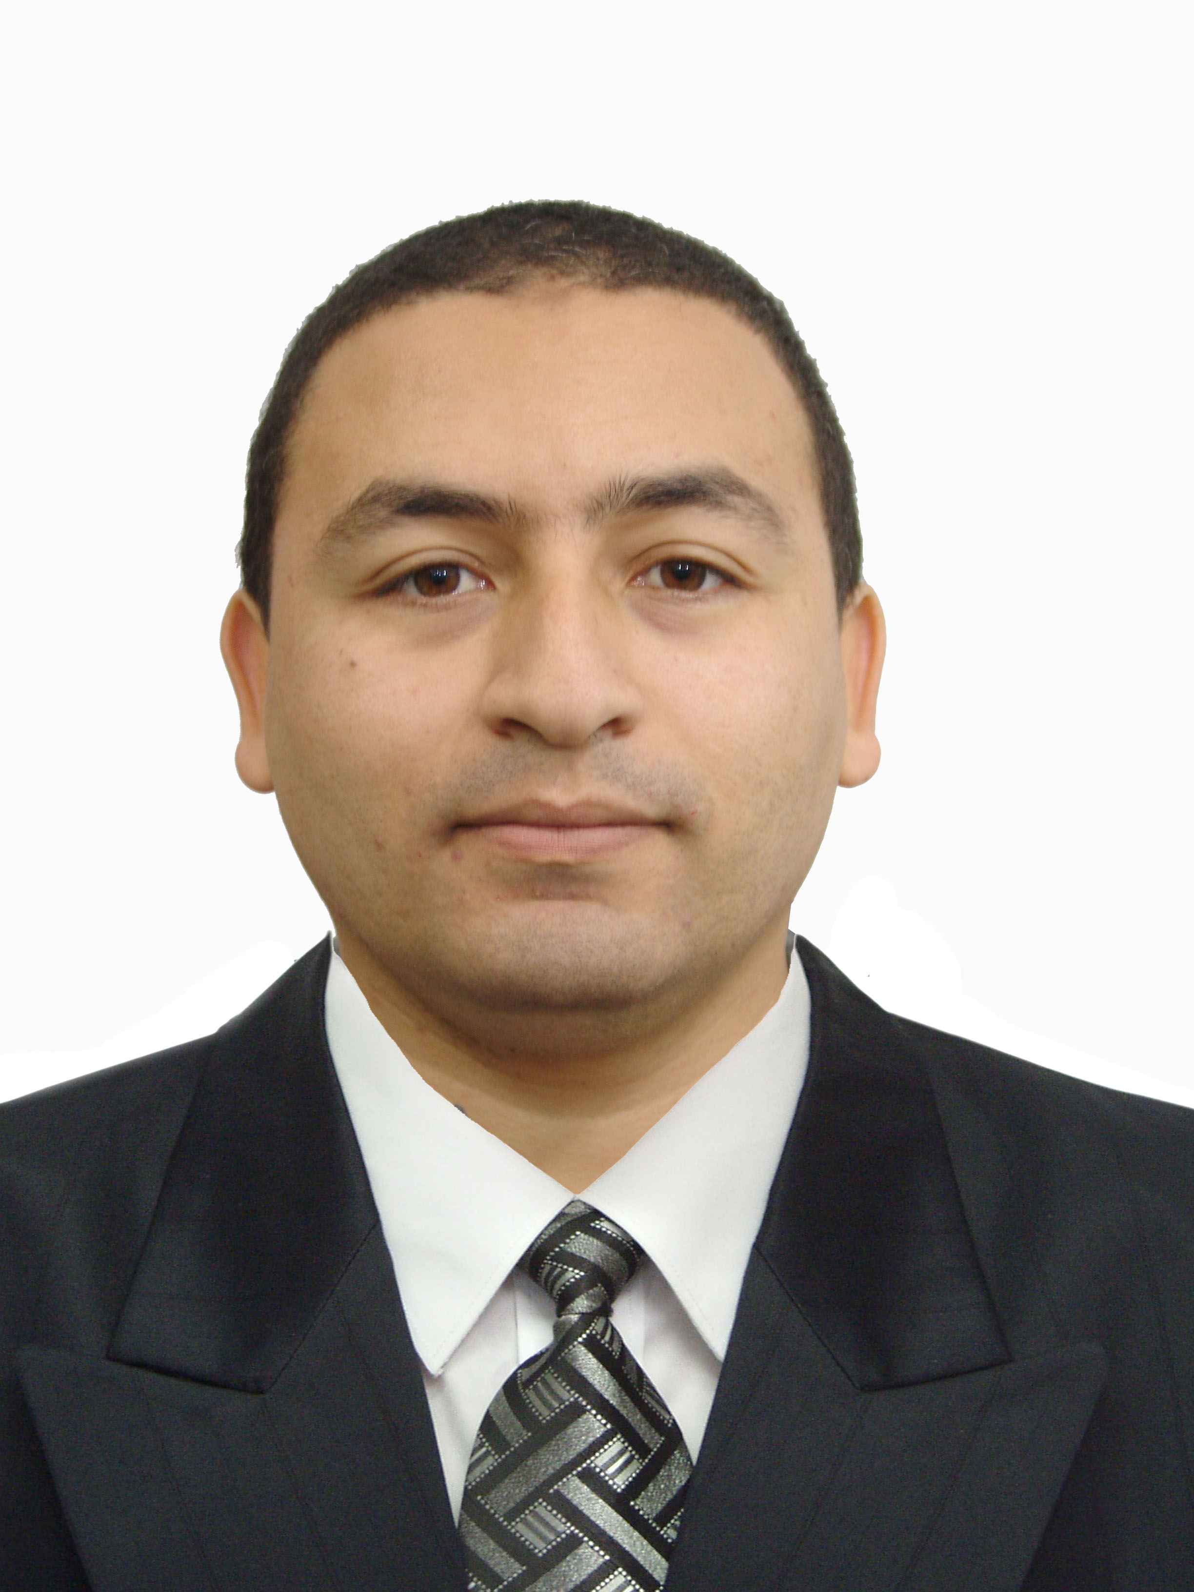
CURRICULUM VITAE
Nekka Salah Eddine Uv1 ulot 3 Bloc T n°441 - Ali Mendjeli-
16/12/1986 Constantine - Algeria  0771818860 : indoushka4ever@gmail.com
Study & Training

- Computer Operator Certificate.
- Certificate Web Application Penetration Testing
- Certificate Advanced Penetration Testing
Vulnerabilities and Security Research

- 2004 – 2023 : Packet Storm Security – Security Researcher–
- https://packetstormsecurity.com/files/authors/7697
- 2009 – 2020 : Offensive Security – Security Researcher–
- https://www.exploit-db.com/?author=2075
- 2010 – 2015 : Injector Security – Security Researcher–
- https://0day.today/author/2151
- 2018 – 2023 : CxSecurity – Security Researcher–
- https://cxsecurity.com/author/indoushka/1/
- 2015 –2016 : NOVISOFT – Consultant –
- 2015 – 2016 : FCE – Consultant –
- 2017 – 2018 : Ayrade Alger – Consultant –
- 2019 : Assabiaa Tv – Consultant –
- 2020 : African Advisory Center for Arbitration and Mediation – Consultant –
- 2020 - 2021 : anbaa-aljazair – Consultant –
Intelligence and Secret Services

- 2011 – 2013 : Military Installations Engineering -Elite Counter Terrorism-
- 2010 - 2015 : Central Directorate of Army Security DCSA -Elite Counter Terrorism-
- 2016 – 2017 : Regional Military Center for Research & Investigations -Elite Counter Terrorism -
- 2018 : National Commission for Combating Communications Crimes -Elite Counter Terrorism-
- 2022 : General Directorate of External Security (DGSE) -Elite Counter Terrorism-
LANGUAGES

- Arabe
- Anglais : bonnes notions

